**EXP NO 8**

**Create storyboards to represent the user flow for a mobile app (e.g., food delivery app) using Balsamiq**

**Mobile Food Delivery App**

To visually represent the user flow of a mobile food delivery app using Balsamiq wireframes in storyboard format.

**Step 1: Set Up Balsamiq**

1. **Go to:** <https://balsamiq.com>
2. **Download & Install** Balsamiq Wireframes (Desktop or use Web app).
3. **Create a New Project** from the dashboard.

Step 2: Define the User Flow (Storyboard Plan)

**Wireframe 1: Home Screen**

**Purpose**: Entry point where users search or choose cuisine.

**Steps:**

1. Draw a **mobile frame outline**.
2. At the top, write the heading: **Home**.
3. Add a **search bar** with a magnifying glass icon.
4. Below that, add 3-4 **buttons** labeled with food categories (e.g., Pizza, Sushi, Burgers).
5. Use simple boxes and rounded corners for input fields.

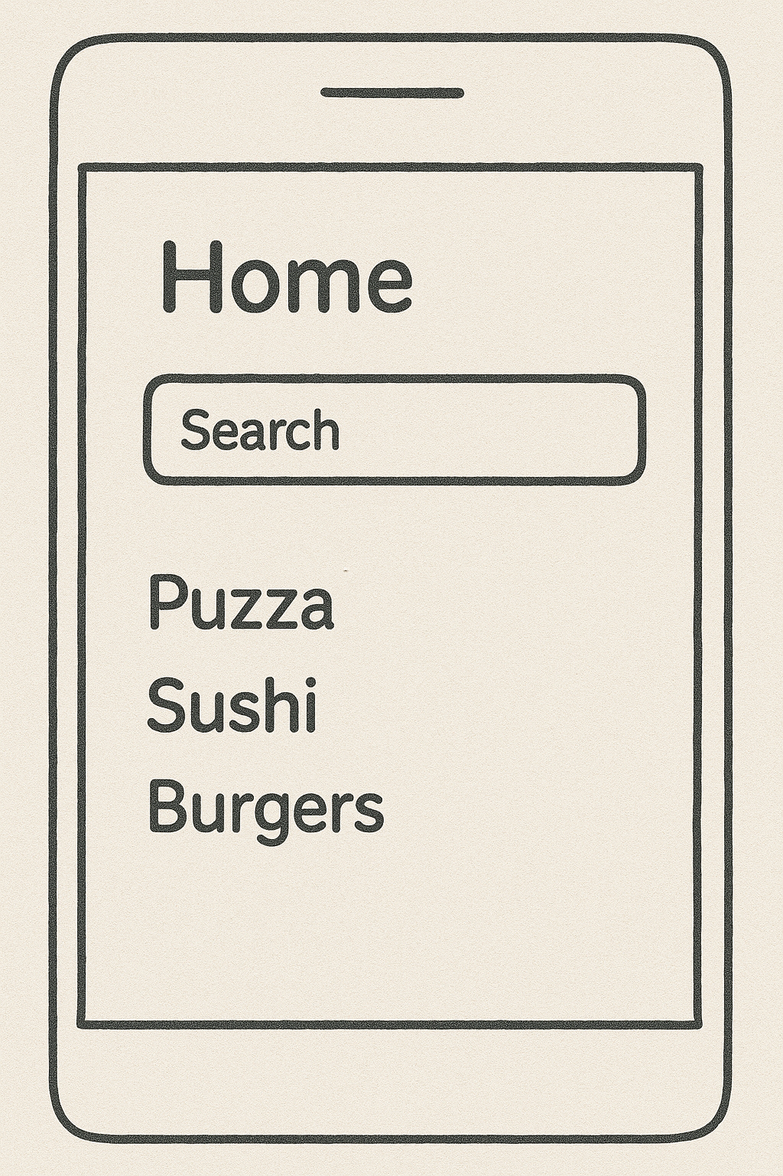

**Wireframe 2: Menu Screen**

**Purpose**: Display food items from a selected restaurant.

**Steps:**

1. Title the screen: **Menu**.
2. Create a **list layout**:
   * A square box for each item (image placeholder).
   * Next to it, write “Food Item”, a sample price ($0.00).
   * Add a **button** labeled "Add to Cart" for each item.

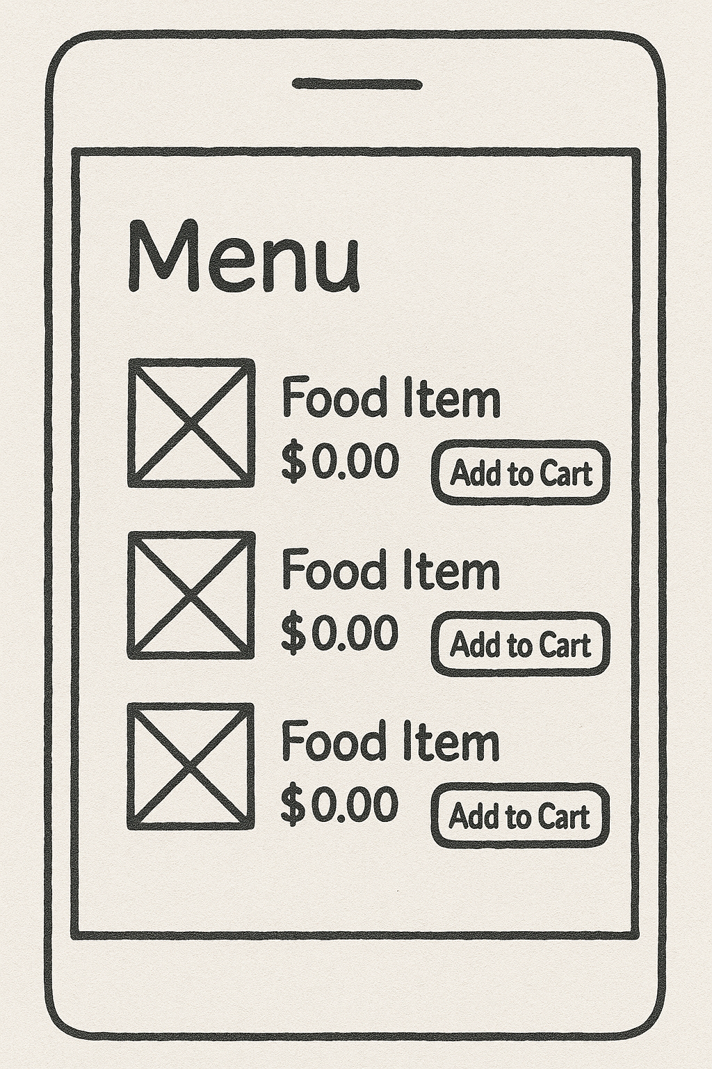

Include 2-3 sample items for consistency.

**Wireframe 3: Cart Screen**

**Purpose**: Show added items and total before checkout.

**Steps:**

1. Title the screen: **Cart**.
2. List 2 items (same format as menu):
   * Image placeholder
   * Item name, quantity (e.g., 1×), price
   * Optional: "Remove" or "Edit" button
3. Show **Total: $0.00**
4. Add a large **"Checkout" button** below.

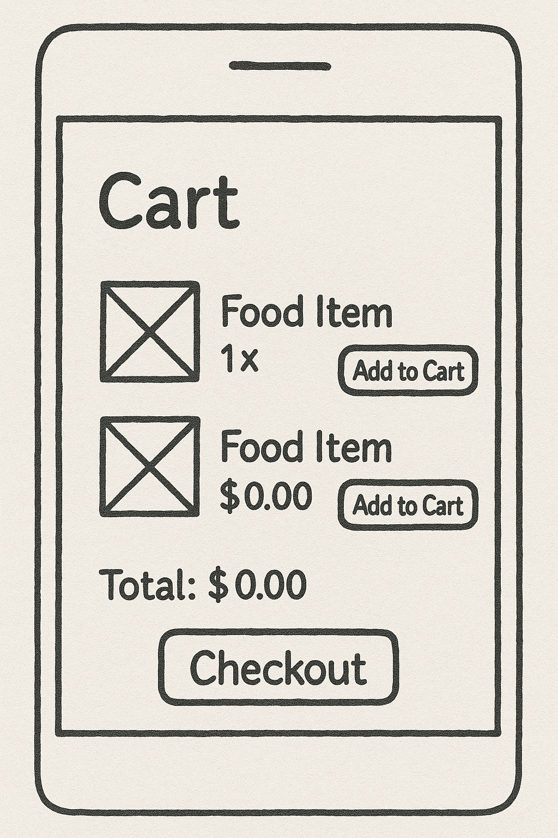

**Wireframe 4: Checkout Screen**

**Purpose**: Collect delivery address and payment details.

**Steps:**

1. Title: **Checkout**
2. Draw a rectangular input box labeled **“Delivery Address”**
3. Below, add a **Payment section** with:
   * Radio buttons for **UPI** and **Cash on Delivery**
4. At the bottom, a large **"Place Order"** button.

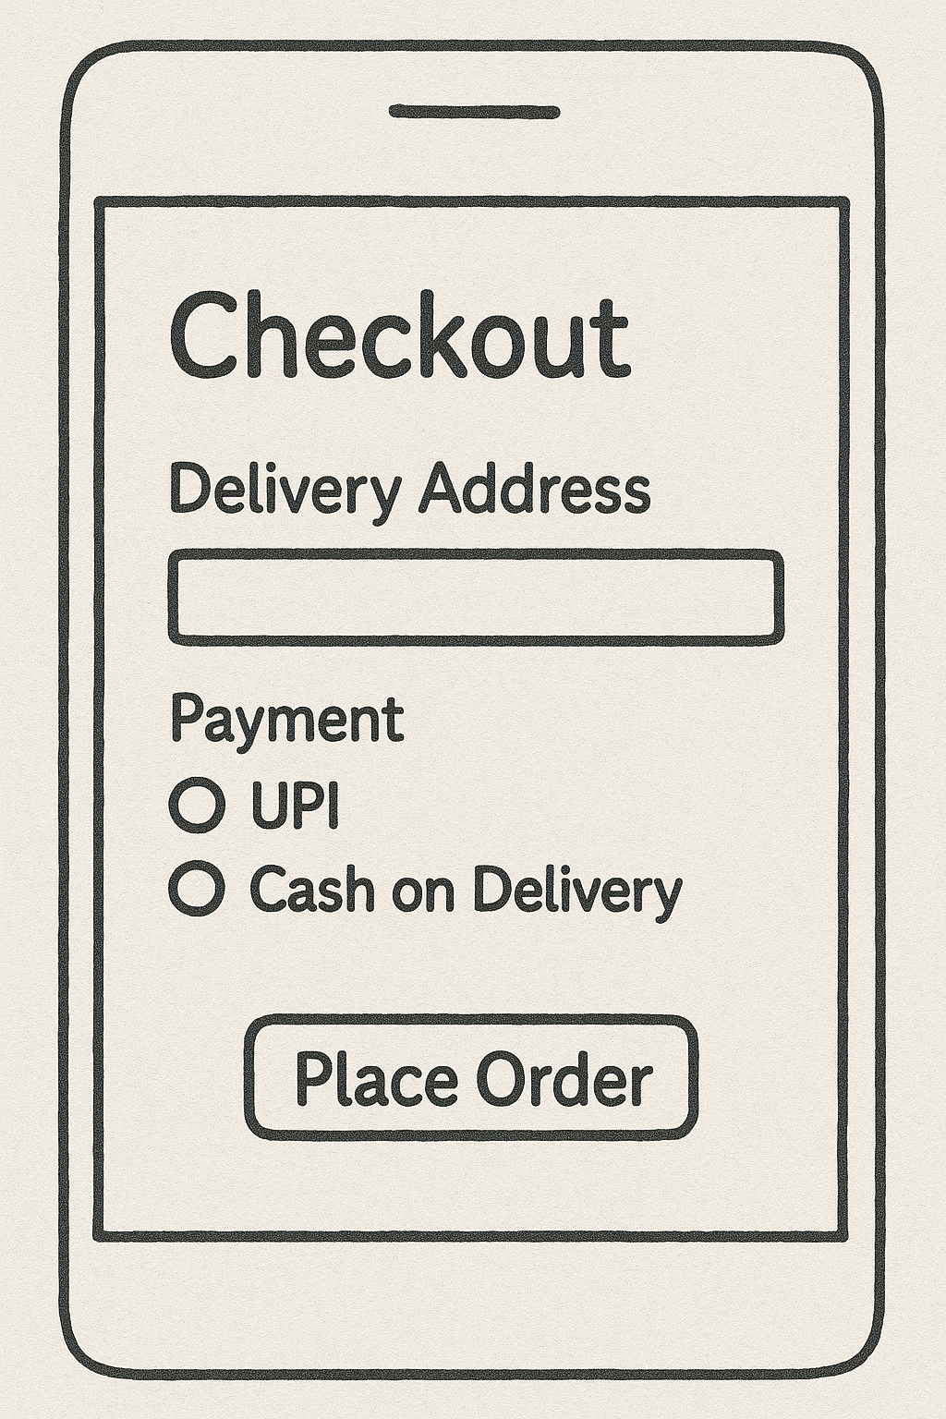

**Wireframe 5: Order Confirmation Screen**

**Purpose**: Confirm successful order and show ETA.

**Steps:**

1. Title: **Order Confirmation**
2. Add a centered message box saying **“Order Confirmed”**
3. Below, include:
   * List of items ordered (e.g., 1× Margherita)
   * Payment method summary
   * Estimated Delivery Time: e.g., **30 min**

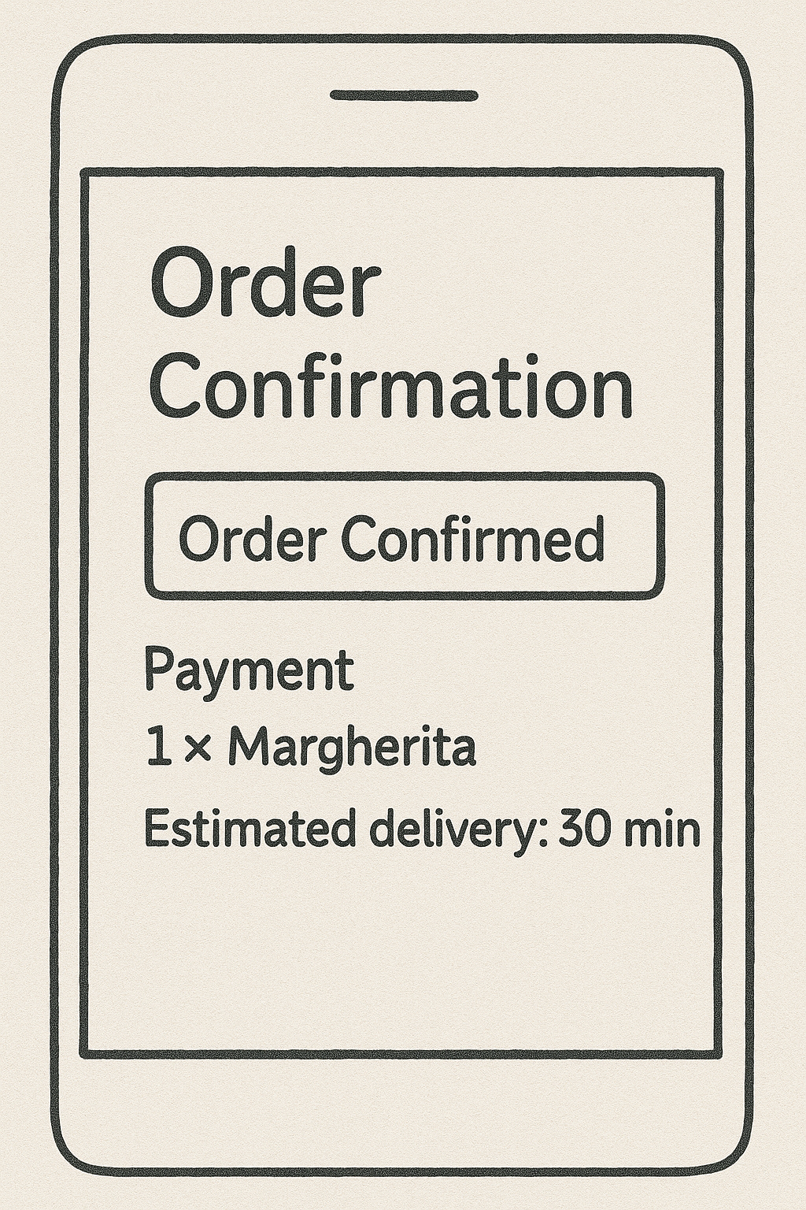

**Step 3: Connect Screens as a Storyboard**

1. **Arrange Screens** horizontally or vertically.
2. Use **Arrows** (from “Markup” tools in Balsamiq) to show the flow:
   * Home → Menu → Cart → Checkout → Confirmation

Finally we have built a **user-centric storyboard** that simulates the real navigation experience in a food delivery mobile app. This helps in **UI/UX planning, prototyping, and user testing** before actual development begins